UK Year 6 – Pre-test
12 Questions | 30-45 minutes | Calculator allowed
1. Draw the reflection of the shape in the mirror line.
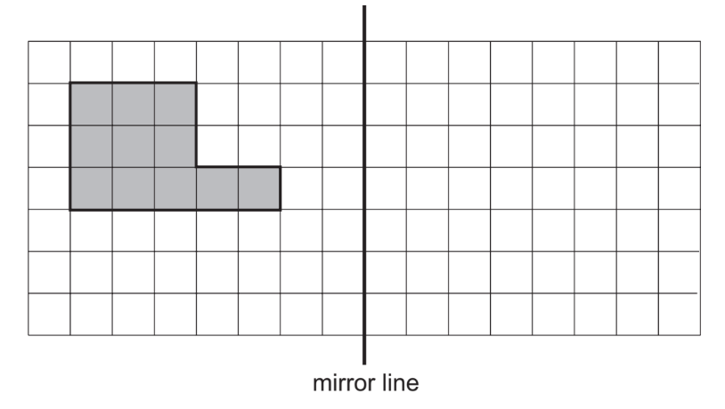
2. Draw a ring around the number which has the digit 5 in the thousands column.

65 302 51 302 69 502 48 352

3. Round 8375 to the nearest thousand. ______________________
Round 3.66 to the nearest tenth. ______________________

4. Here are four digit cards.
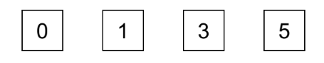
Use these cards to complete this calculation. Each card must only be used once.
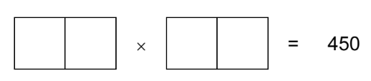
5.
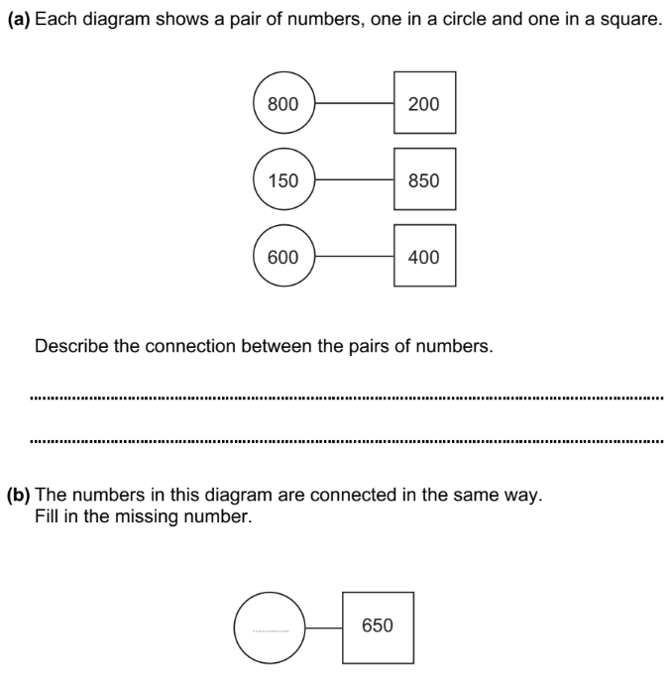
6. Complete the table of equivalent fractions, decimals and percentages.
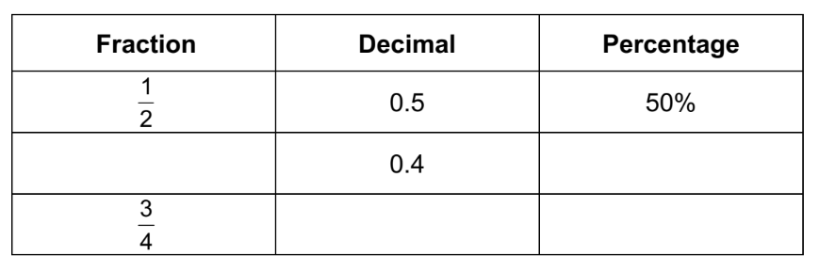

7. A model of a car is one tenth of the size of the real car.
The model measures 42 cm long.
What is the length of the real car?
Give your answer in centimetres.

_________________________cm

8. Here are 2 triangles on a grid.
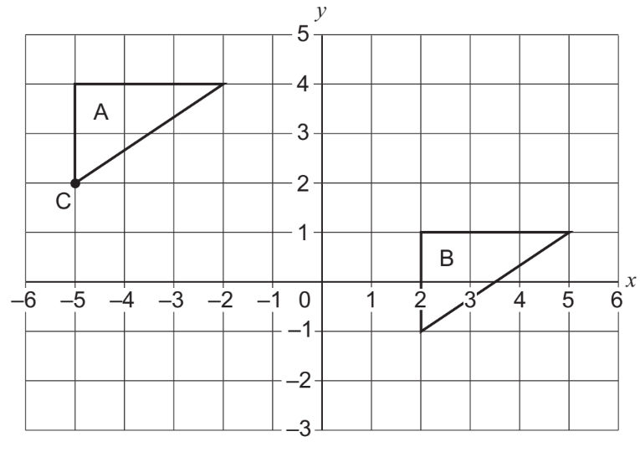
What are the co-ordinates of point C? ( __________ , __________ )
Describe the translation that moves triangle A to triangle B.
______________________________________________________________________

9. A glass holds 225 millilitres of water.
Peter drinks 1.8 litres of water during a day.
How many glasses of water does he drink during the day?
______________________________ glasses.
10. Write the next three numbers in the sequences.

2, 3, 5, 7, 11, ____________, ____________, ____________

1, 4, 9, 16, 25, ____________, ____________, ____________

11. The price of a coat is $45
In a sale the price is reduced by 15%.
Work out the price of the coat in the sale.

$_________________________

12. Here is part of a train timetable.
Both trains take the same time to travel between stations.
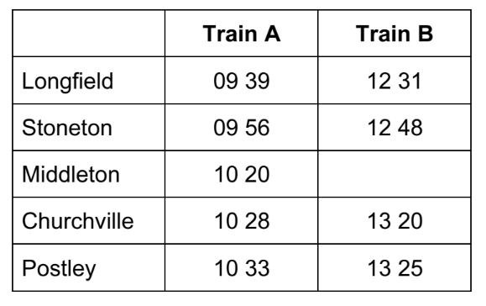
Fill in the missing time for Train B.
What is the journey time between Longfield and Churchville?

_________________________ minutes

